# Project Statement

# SIR model

SIR model is a classical theory model for the prediction of pandemic. It splits the population into three compartments including Susceptible, Infectious and Recovered. The theory allows us to describe the number of people in each compartment with the ordinary differential equation thus easy to get the step-wise simulation.

There are 2 determinant parameters in the model. β represents the number of people that an infected person could affect. γ represents the chance for an infected person to get recovered. Another important idea which is usually mentioned is R0, the basic reproduction number. This is an epidemiologic metric used to describe the contagiousness of a pandemic which could be calculated by:

# EDA

## Data

|  |  |  |
| --- | --- | --- |
| Item | Source | Content |
| County Level Mobility Index | [Google Mobility](https://www.google.com/covid19/mobility/index.html?hl=en) | The strength of mobility in six categories comparing to the baseline period. Six categories are: retail, groceries, parks, transit, workplaces and residential |
| State Level Policy Database | [Boston University Researchers](https://docs.google.com/spreadsheets/d/1zu9qEWI8PsOI_i8nI_S29HDGHlIp2lfVMsGxpQ5tvAQ/edit#gid=973655443) | The policy database collected comprehensive policies implemented within the US to control COVID-19 pandemic, including “shelter-in-place”, “stay-at-home”, “restaurant / bar / theater closure” etc. |
| County Level COVID-19 Database | [Johns Hopkins University](https://github.com/CSSEGISandData/COVID-19/tree/master/csse_covid_19_data/csse_covid_19_time_series) | The confirmed cases and deaths from January 21st to present. |
| County Level Demographic Database [1] | 2014-2018 American Community Survey extracted by tidycensus package | Female_percentage, Median_age, population, Latitude, Longitude |
| County Level Demographic Database [2] | [2017 American Community Survey](https://www.kaggle.com/muonneutrino/us-census-demographic-data?select=acs2017_county_data.csv) | Racial composition, Work Type, Income, Transportation Mode, Employment Types |

## Preprocessing

In our project group, each member was assigned the task to collect data for county social demographics, covid-19 cases, policies and mobility. To be integrated easily by others, each of us are supposed to aggregate the data and generate the processed csv/excel file which includes unique fips code.

**Mobility Index:**

Currently we choose to drop all NAs in our database and reserve qualified rows only.

**Policy:**

The raw data has multiple lines to represent each state and multiple columns to represent the start date or end date of policies. To be able to join with the daily cases data, we convert the policy data into dummy variables thus having a time series policy Dataframe.

**Socio-Demographics:**

State_code is missing for Puerto Rico which we dropped; ChildPoverty is filled with median value for the missing counties in Hawaii; Crime variables are filled with median value for 7 counties in Alaska, 1 county in New Mexico and South Dakota.

**COVID-19 cases:**

We applied the 7-day moving average to conquer the problem of weekly effect. Two new columns are generated: cases_7 and deaths_7.

## Selected Figures

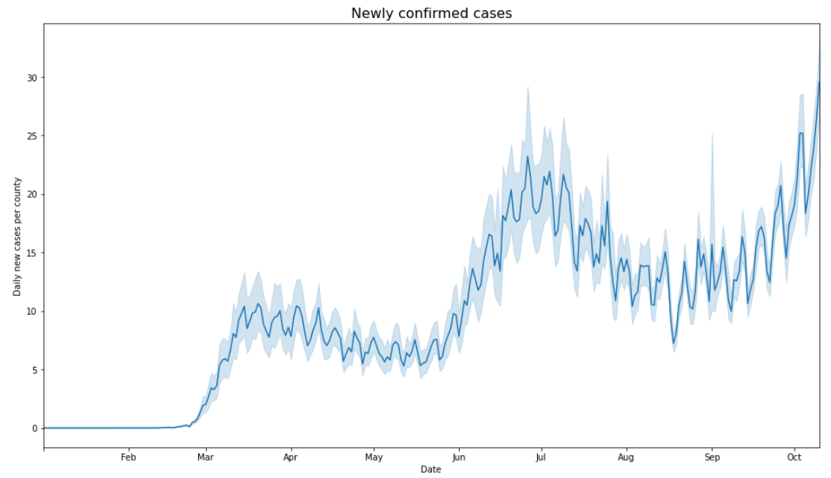

Fig 1 Weekly circular patterns in the newly confirmed cases

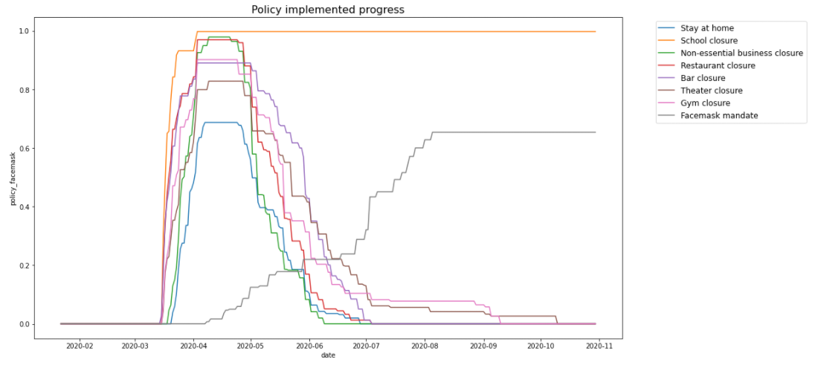

Fig 2 Except for facemask mandates, most policies are implemented around the same time period

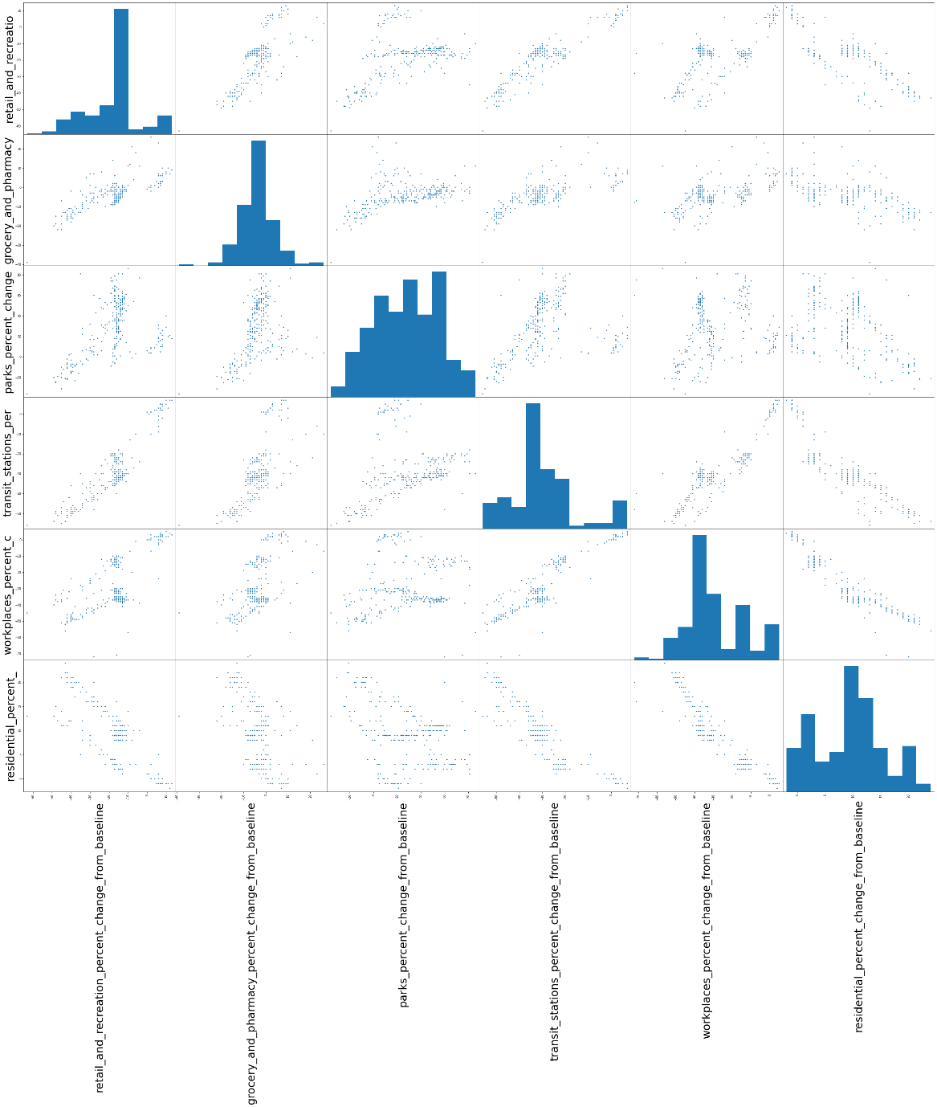

Correlation between Mobility Index

Fig 3 We can see strong correlations between some index. For example, workplaces_percent is strongly correlated to transit

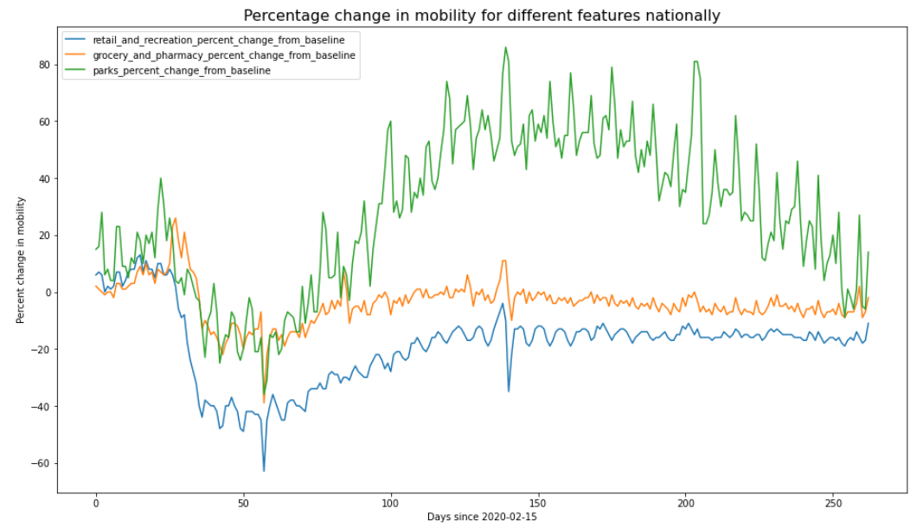

Fig 4 Comparing to other mobility index, park visitation experienced a clear increase and decrease

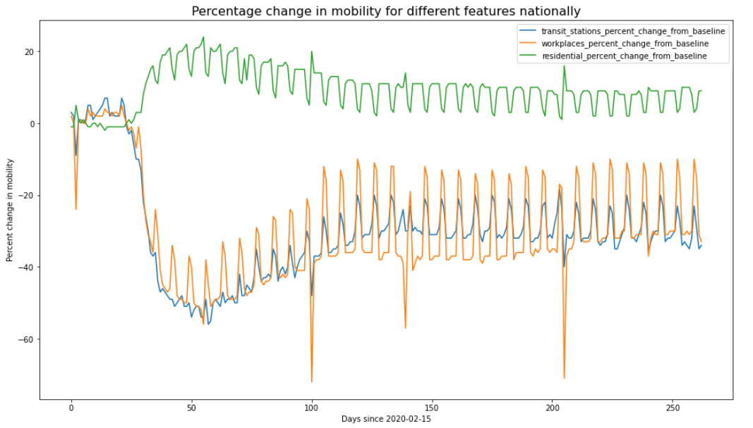

Fig 5 There is strong weekly pattern in the index related to work and transportation. The valley of workplaces might because of holidays.

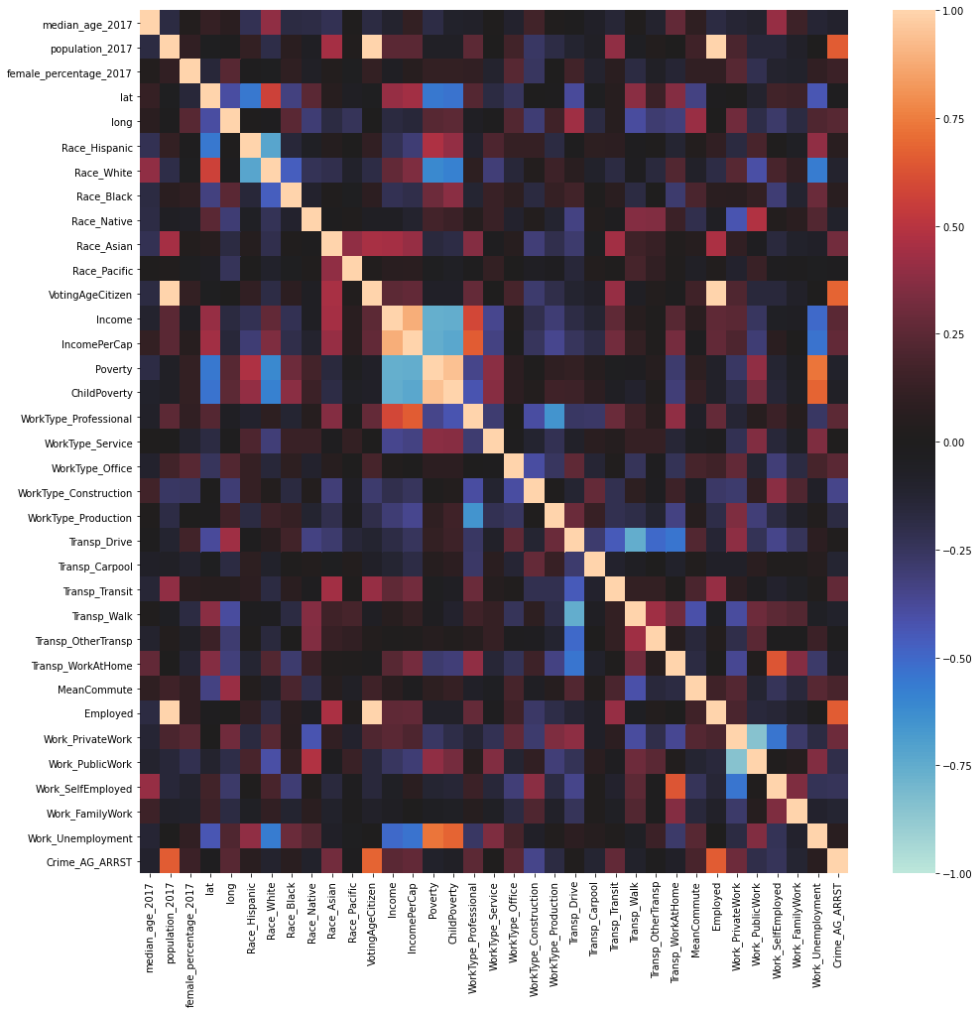

Fig 6 Correlation between demographic features

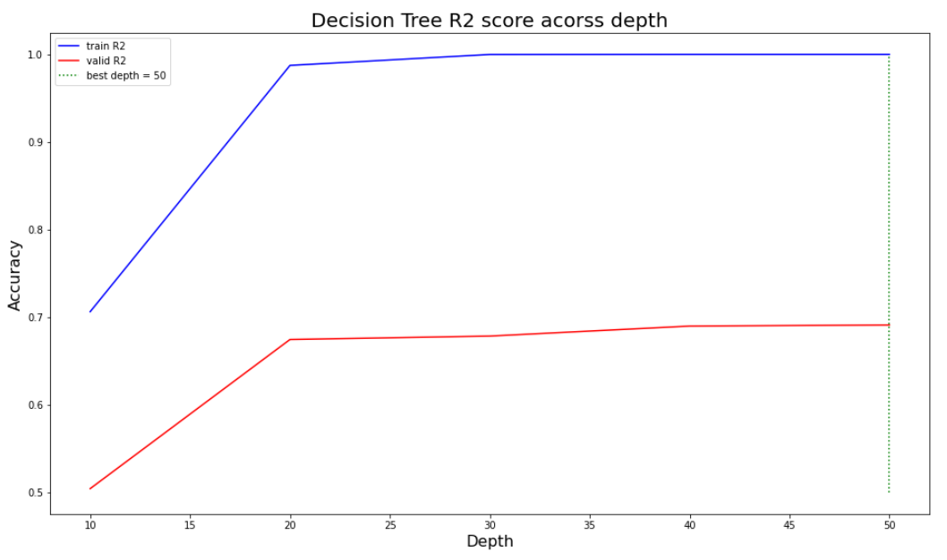

Fig 7 We implemented a decision tree regression to predict the COVID-19 growth rate (β). The R2 score achieves 0.69 on validation set.